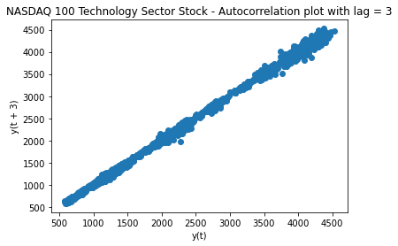

The above model shows that there is a strong auto-correlation for this data and the ARIMA model is a good tool to use for this particular data set.

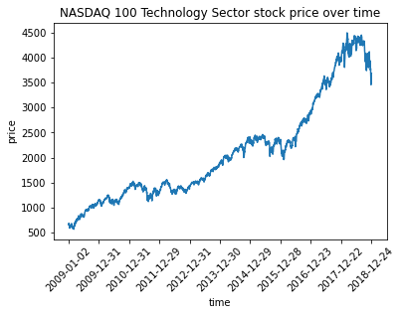

A line graph that shows NASDAQ 100 Technology Sector stock price from 2009 through the end of 2018

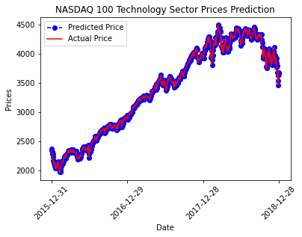

Above is the test data that has been compared to the actual predicted price. Our model was ran with a 70/30 split of training and testing data sets.

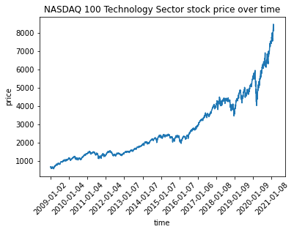

A chart showing a complete data set of actual stock prices through the end of 2020.

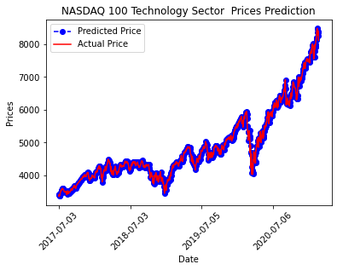

The final chart of the complete data set shows how the ARIMA model was able to closely predict the stock price as it moved through the end of 2020.

Overall ARIMA is a great model to show a machine learning time-series example. A few other use cases for ARIMA, and time-series, models are housing prices over time and temperature values over time. One of the challenges with the ARIMA model is that it is predicting the stock price along side the training data, where as the prophet model allows for the user to predict into the future and then compare that against the actual data in a separate chart.

Both time series models are particularly good examples of how machine learning works to segment the data into separate data sets and generate a multitude of possible outcomes. Facebook prophet would be a better representation of what we were looking for in this project as it was able to predict into the future without running directly along side the training data. Although Facebook prophet is not perfect, and the stock market has too many outside influences for these models to work, it was able to predict a steady incline over time.

FB Prophet:  
·       Fig1: 2009-2018 data used to predict what the results will be through 2019  
              According to the Facebook Prophet algorithm the “Closing Price” for the Nasdaq 100 Tech sector stock will continue a gradual incline into the year 2020. The actual results of Q4 in 2018 are showing signs of a decline in closing price, but the model has not reflected that in its predicted outcome.·

The 2018 decline was something caused by factors that cannot be represented in this model. Examples of outside influences include the Trump administration’s Tariffs, Federal reserve raising interest rates, Big Tech companies facing major scrutiny, Inflated company earnings, and GOP tax cuts put into place at the end of 2017.

Fig2: 2009-2020 data used to confirm/reject what the previous model predicted  
              Once we ran the actual numbers for 2019 through the same model, we confirmed that the closing price did in fact bounce back and continue on it’s projected growth pattern. In fact, the actual data proved to exceed the predictive model and have a higher closing price that what was generated in the graph.·

Fig3: Market trends over the years

There are several trends established by using the Facebook Prophet approach. It has the ability to show when a stock could possibly be at purchased at it’s lowest price, when a stock could be affected by seasonality, or how holidays could impact the outcome of the closing price. Our model was able to determine that the Nasdaq 100 Technology sector will continue to go up given the previous trends. It also shows the closing price generally increases to it’s highest point on Tuesdays and declines as the week progresses. It was also able to determine that closing prices are up almost 75% in the year’s first quarter and taper off significantly as the seasonality changes and holidays hit. The Nasdaq 100 Technology sector is not a good stock to measure on a daily basis, as there is not enough evidence to predict how the prices may fluctuate throughout the day.

Challenges:

* Importing the necessary libraries to run Facebook prophet
* Adjusting the parameters for the individual models to reflect the data in the most accurate way
* Researching and understanding some high-level statistical terms to translate and tune the individual models
* Long run times. Particularly for the ARIMA models